Practise problems

- Calculate the phasor currents and in the circuit shown in figure 1.
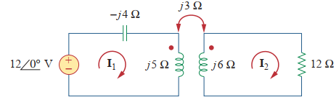
Figure 1

- Calculate the mesh currents and in the circuit shown in figure 2.
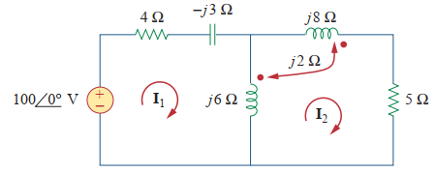
Figure 2

- Consider the circuit in Figure3. Determine the coupling coefficient. Calculate the energy stored in the coupled inductors at time t=1sec if v=60cos (4t+30º) V.
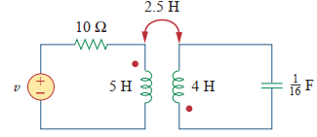
Figure 3
- In the circuit of figure 4, calculate the input impedance and current I₁. Take Z₁=60 - j100Ω, Z₂=30 + j40 Ω and Z_{L}=80 + j60Ω.
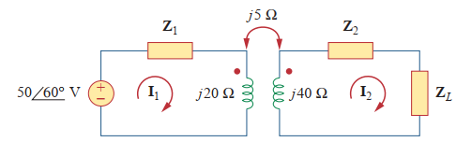
Figure 4
- Calculate I₁, I₂, V_{o} from the below circuit shown in figure 5.
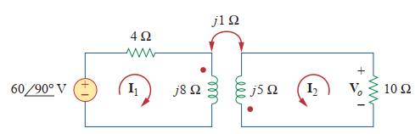
Figure 5

- The coils in figure 6 shown below have L₁=40mH, L₂= 5mH and coupling coefficient k=0.6. Find i₁(t), v₂(t). Given that v₁(t)=10cos(wt) and i₂(t)=2sin(wt) where w=2000rad/sec.
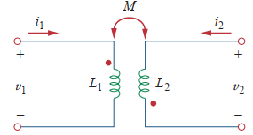
Figure 6
- For the circuit shown in figure 7. Find V_{o.}
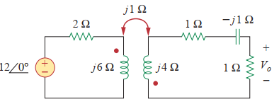
Figure 7.
- Find v(t) for the circuit in figure 8.
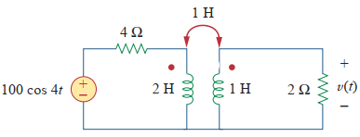
Figure 8
- Find V_{x} in the network shown in figure 9.
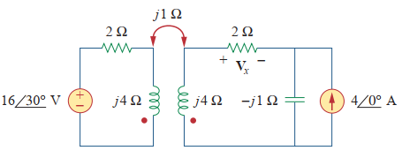
Figure 9
- Find V_{o} in the below circuit shown in figure 10.
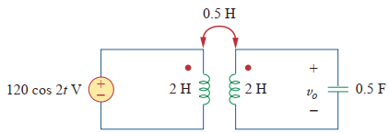
Figure 10
- Use mesh analysis to find i_{x} shown in figure 11 where i_{s}=6cos(600t) A and v_{s}=165cos(600t+30º) V.
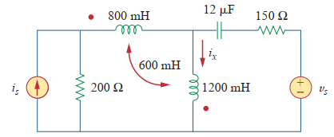
Figure 11

